**Info**

* Structures stores heterogeneous elements.
* Which of the following operators can be used with structures?
* =
* Struct point p1 {
* Int x,y,z;
* }
* Struct point p1 = {.y = 0,.z = 1,.x = 2}
* We can represent a struct variable in the necessary function

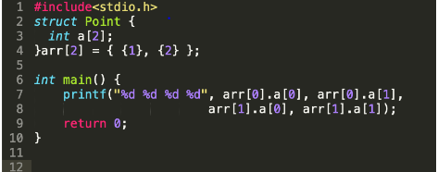

* In first index arr[0] stores the values of a[0] 1020
* .(op) is used to access the structure members.

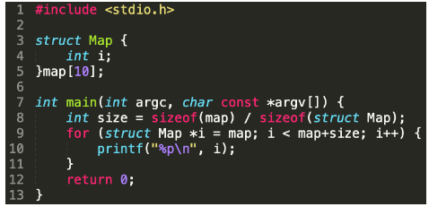

* When you do i++ in for loop, it points to the next struct object’s address.
* The base address of the map is assigned to i and then iterates for 10 times that prints its address.
* t iterates all the objects of map and prints its address

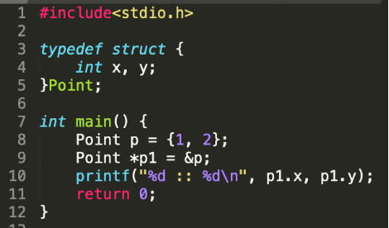

* Pointers should be declared by ->
* Where is the compiler error in the following code snippet?
* 4 and 5 because declarations are not allowed

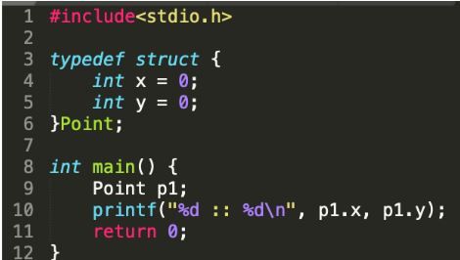

* What are the max and min values that you can store in x and y?
* An unsigned short int can store min = 0 and max = 2 ^ 16
* If we represent : then only that bits are allocated.1 = 0 1(0,1)
* (max,min)
* 2 00 01 10 11(0,3)

